AI ASSISTED CODING
Name:A.SaiTeja
Ht.No: 2303A52167
Batch:35
Assignment-5.1
Task-1: Use an AI tool to generate a Python program that connects to a weather API.
PROMPT: Generate a Python program that fetches current weather data from a public weather API. The API key should NOT be hardcoded in the program. Use environment variables to access the API key securely and explain why this method is safer.
CODE:
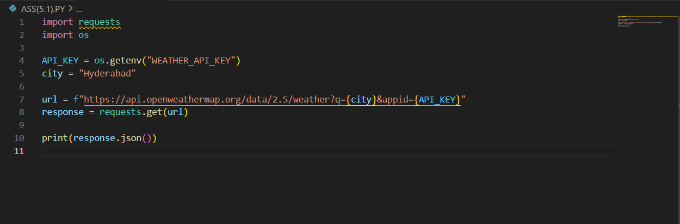
OUTPUT:
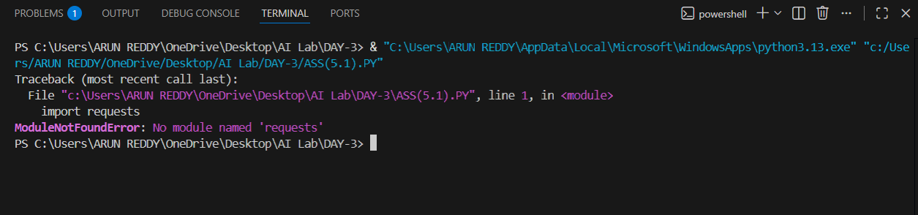

TASK-2: Use an AI tool to generate a Python script that stores user data
(name, email, password) in a file.
PROMPT:
Generate a Python program that stores user data such as name, email, and password into a file. After generating the code, analyze whether storing passwords in plain text is safe. Then provide a secure version using password hashing or encryption with proper explanation.
CODE:
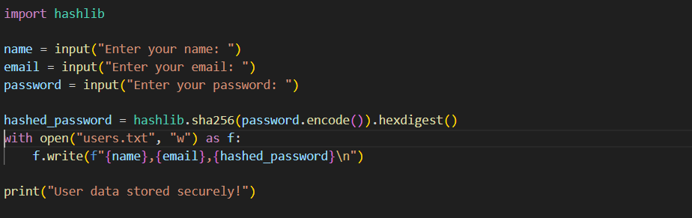
OUTPUT:
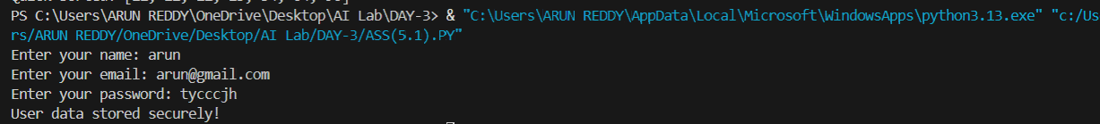

TASK-3: Use AI to generate an Armstrong number checking function
with comments and explanations.
PROMPT:
Generate a Python function to check whether a number is an Armstrong number. Add clear comments for every step in the code and explain each line in simple language so that a beginner can understand the algorithm.
CODE:
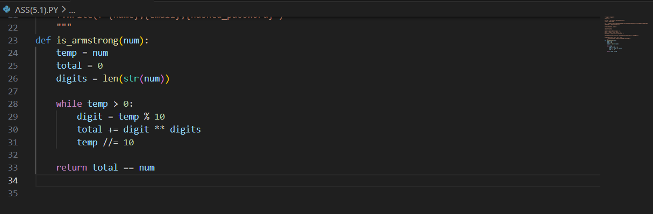
LINE-BY-LINE EXPLANATION:
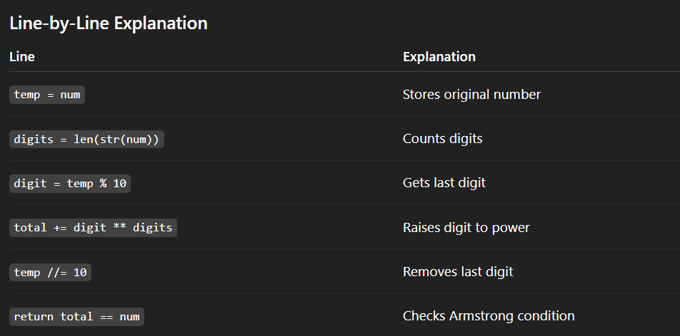

TASK-4: Use AI to implement two sorting algorithms (e.g., QuickSort and
BubbleSort).
PROMPT:
Generate Python code for Bubble Sort and Quick Sort algorithms. Add step-by-step comments explaining how each algorithm works. Then compare both algorithms in terms of logic, time complexity, and efficiency.
CODE:
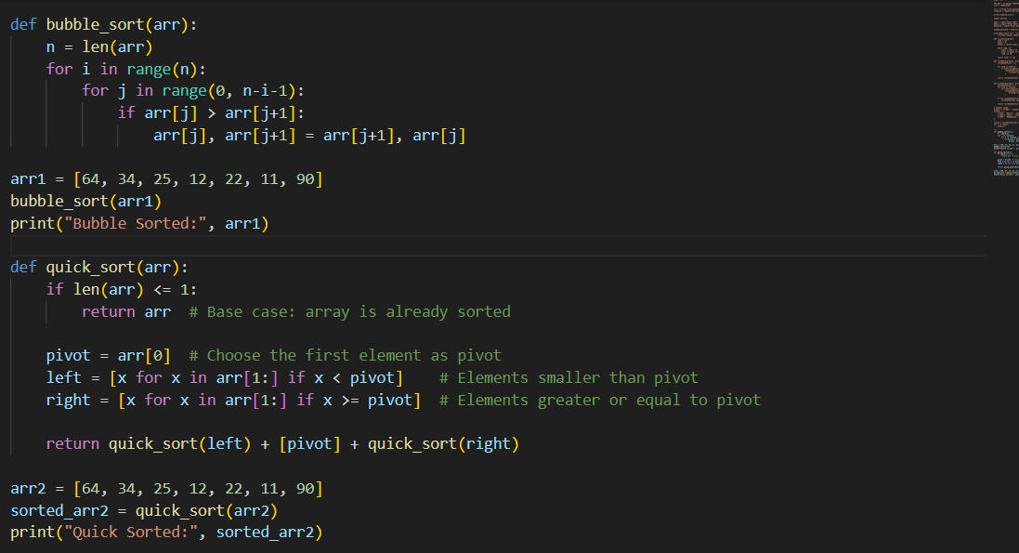
OUTPUT: 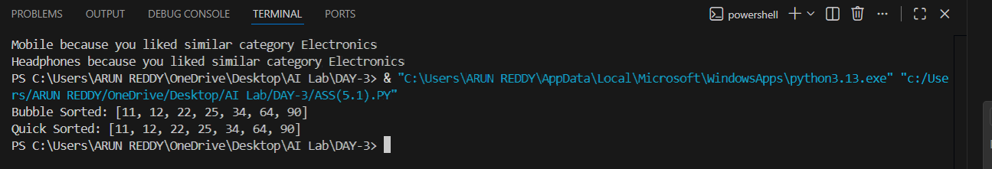COMPARISON TABLE:
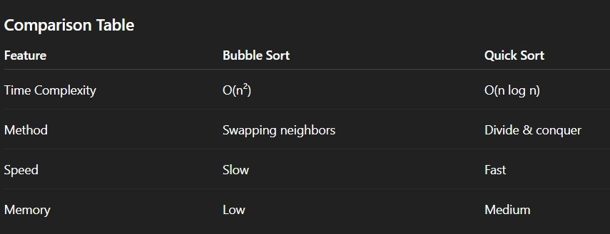

TASK-5: Use AI to create a product recommendation system.
PROMPT:
Generate a simple product recommendation system in Python. The system should not only recommend products but also clearly explain the reason behind each recommendation so the user can understand why the product was suggested.
CODE:
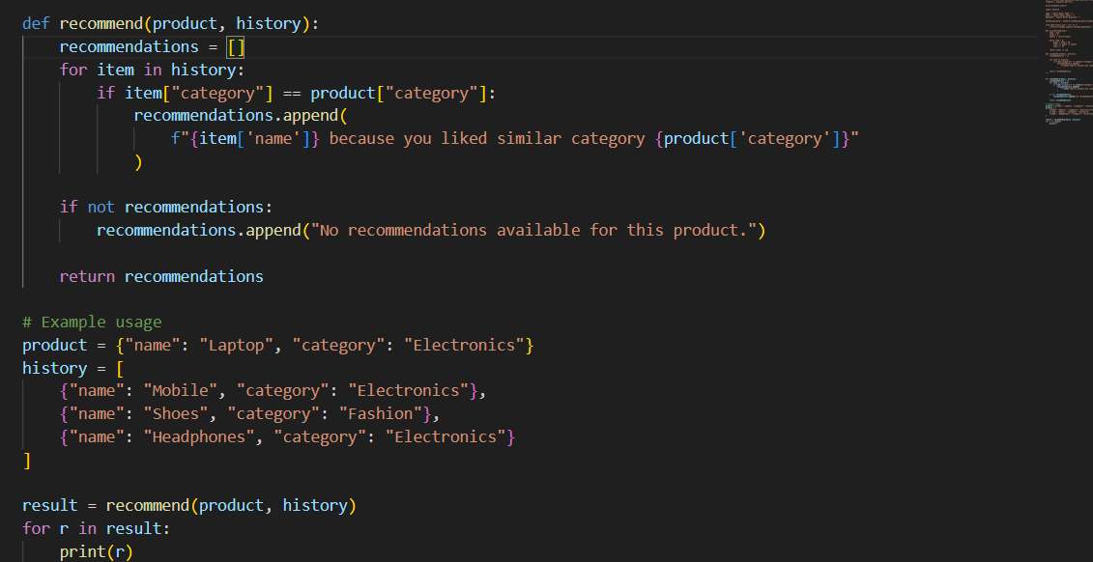
OUTPUT:
